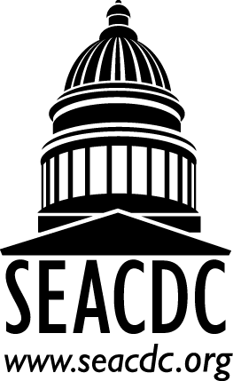 | SEACDC Quarterly Call  May 2, 2017  3:00 PM EST  2:00 PM CT  1:00 PM MT  Audio Conference Details:  Conference Number(s): 1-800-832-0736  Conference Room Number: 5421594  To join the online meeting:  https://vdoe.adobeconnect.com/r52mr568i5o/

Introductions: Who’s on the Line?
New Business
- Nominations for SEACDC Board Positions
  - Secretary and President Elect
- ASHA Elections open until May 31st. Please encourage professionals to vote.
  - ASHA BOD positions and Advisory Council for Select States
- Annual Meeting
  - Suggested topics (feedback survey will be sent via email)
  - Travel Invitation and Registration for Annual Meetings (coming soon)
- ASHA Connect: July 2017
  - Please consider coming to the following if you will be at the conference:
    - SEACDC Poster - Please attend and support the SEACDC
    - 2 Presentations: Verna Chinen on How Assessment Guides Treatment and Marie Ireland on Dynamic Assessment
- SEACDC Email and List serve: Communication to members and others
- Possible topics for ASHA & SEACDC Summer Board call
- Research Collaboration Update: School Practice Survey Coming Fall 2017

Other Business:
Review ASHAs caseload chart - please review this document and contact schools@asha.org is you have any corrections or changes http://www.asha.org/uploadedFiles/ASHA/Practice_Portal/Professional_Issues/Caseload_and_Workload/2015-2016-State-Caseload-Sizes-for-School-SLPs.pdf

Group Discussion:
What topics are important in your state right now?
- Compliance/Performance Issues
- Funding (IDEA and/or Medicaid) Issues
- SLP Practice (Assessment/Therapy/Recruitment) Issues

Next Quarterly Call: September 27, 2017

